Name of surveyor: ______________________________________ Date: ______________Team Name_________________________
Field team members: __________________________________________________________________________________________
Site name/number: _________________________Watershed: _________________Stream/beach/park name: __________________
Survey area with points (use GPS if available) ______________________________________________________________________

Table 1. Tally the times that you see the following possible sources of pollutants in your survey site.

Pollutant | Number of times observed | Total | 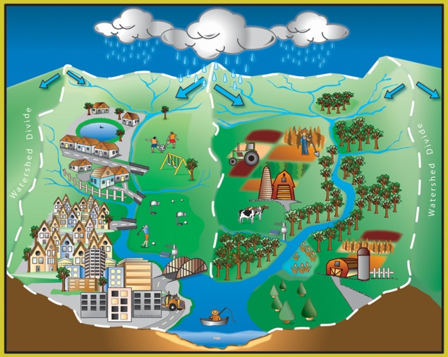  Notes
Pieces of litter
Bare soil (area with no plants or vegetation)
Erosion (loose dirt on stream bank, sidewalk, parking lot, etc.)
Oil (leak from vehicle) or other chemicals
Grass, leaves, or yard clippings
Animals (cats, cows, dogs, goats, horses, etc.)
Other: |  |  | What’s in your watershed?

Discussion questions:
- What are the top 3 most common pollutants found in this part of the watershed? (use the totals from Table 1) ___________________________________________________________________________________________________________________

- What can we do to try and reduce the top pollutants at this site? List at least 2: ___________________________________________________________________________________________________________________

Table 2: Tally the number of native and non –native or invasive plants found in your survey site.
Native plant | Pili grass | Ilima | Koaia | ‘A’alii | Iliahi | Pohinahina | Naupaka | Ohia | Makaloa | Other:
Native plant picture

Number observed
Total
Non – native or invasive plant | Ginger | Christmas  Berry | Fountain grass | Kikuyu grass | Fire weed | Castor bean | Cane grass | Pine (sp?) | Kiawe | Other:
Non – native or invasive plant picture |  | 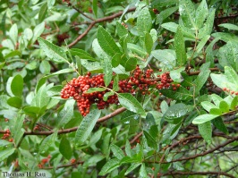 | 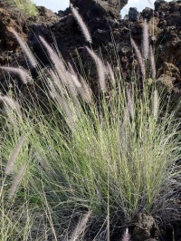 | 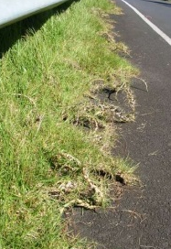 | 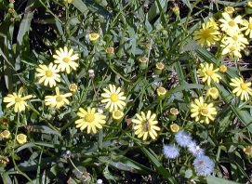 |  | 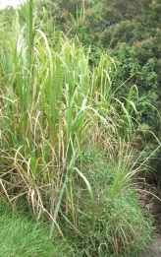 | 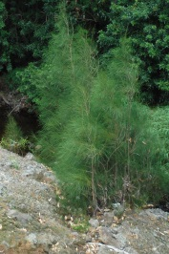 | 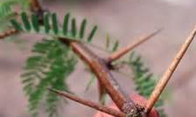
Number observed
Total
- List the top 3 native plants found in this part of the watershed? (use the totals from Table 2) __________________________________________________________________________________
- List the top 3 non -native/ invasive plants in this part of the watershed? (use the totals from Table 2) __________________________________________________________________________________
- What surprised you most about this part of your watershed? __________________________________________________________________________________

